DATA ANALYTICS SQL ASSIGNMENT 1 :
DDL COMMANDS & CONSTRAINTS
TOOLS : MYSQL / MYSQL WORKBENCH
PROJECT OBJECTIVE : DATABASE CREATION, TABLE ALTERATION,
CONSTRAINTS AND DATA INTEGRITY
DATE OF SUBMISSION : 11/09/2026 – 1:30PM

1) DATABASE CREATION:
1.1) CREATE THE "EMPLOYEE" DATABASE.
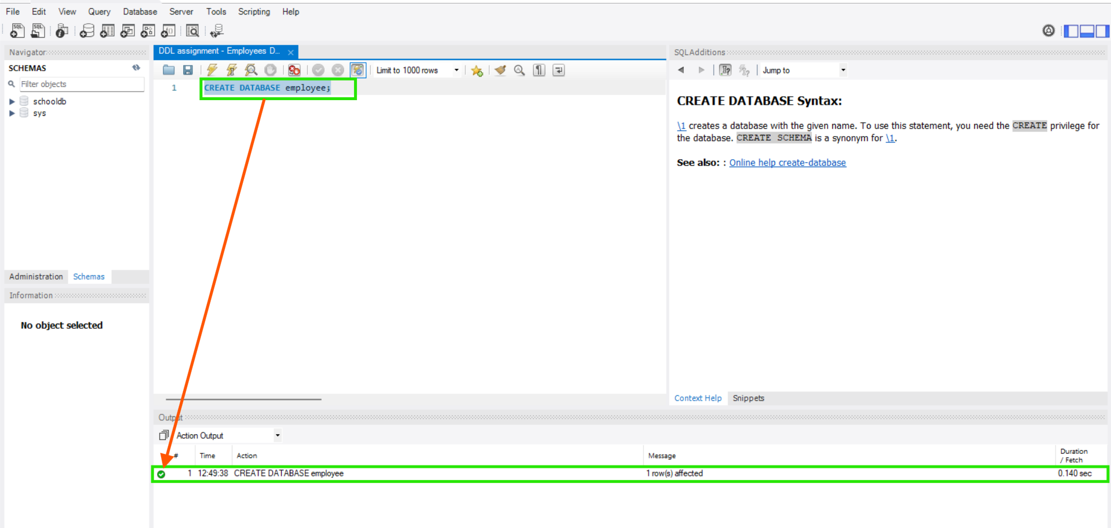
1.2) SELECT THE "EMPLOYEE" DATABASE TO USE FOR SUBSEQUENT COMMANDS.
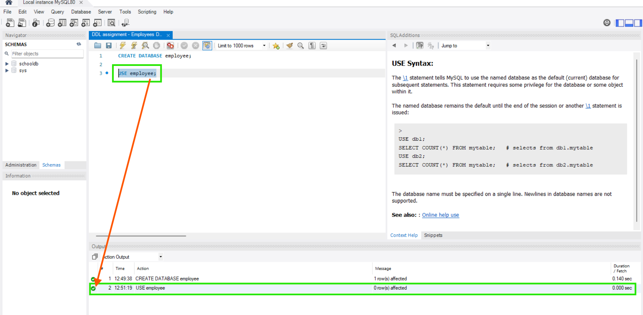

2) TABLE CREATION:
2.1) CREATE TABLE "DEPARTMENTS" WITH COLUMNS "DEPARTMENT_ID" AND "DEPARTMENT_NAME".
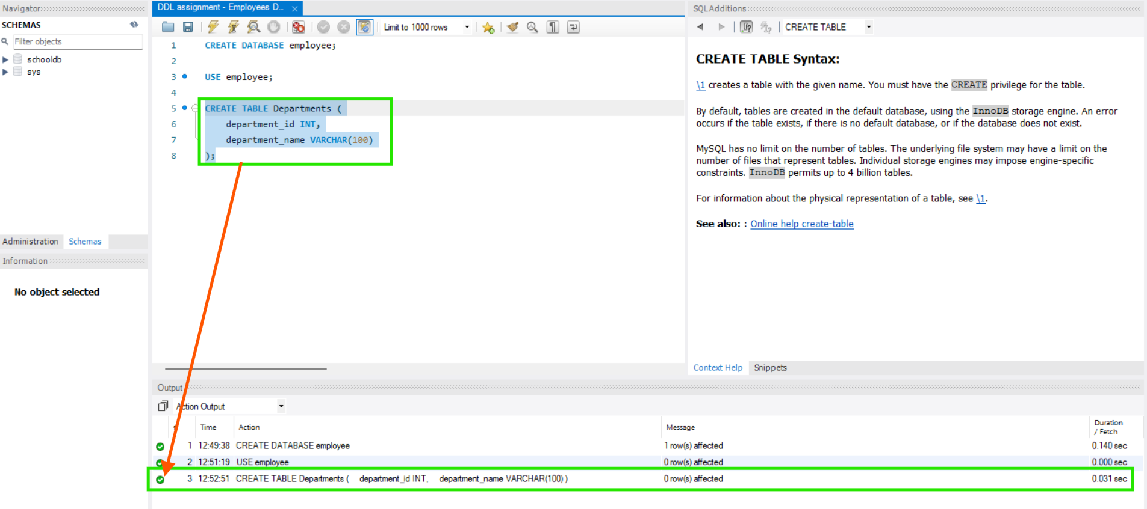
2.2) CREATE TABLE "LOCATION" WITH COLUMNS "LOCATION_ID" AND "LOCATION".
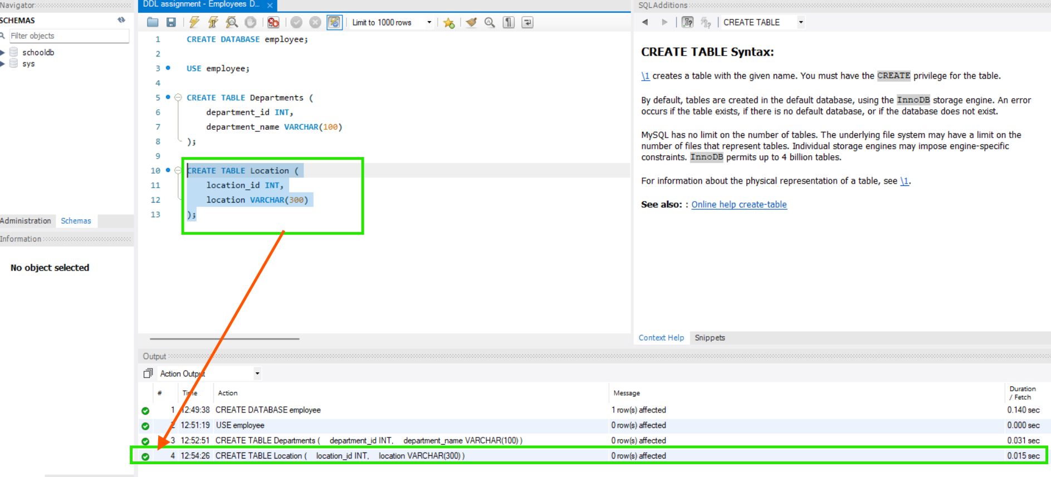

2.3) CREATE TABLE "EMPLOYEES" WITH COLUMNS FOR ID, NAME, GENDER, AGE, HIRE DATE, DESIGNATION, DEPARTMENT, LOCATION AND SALARY.
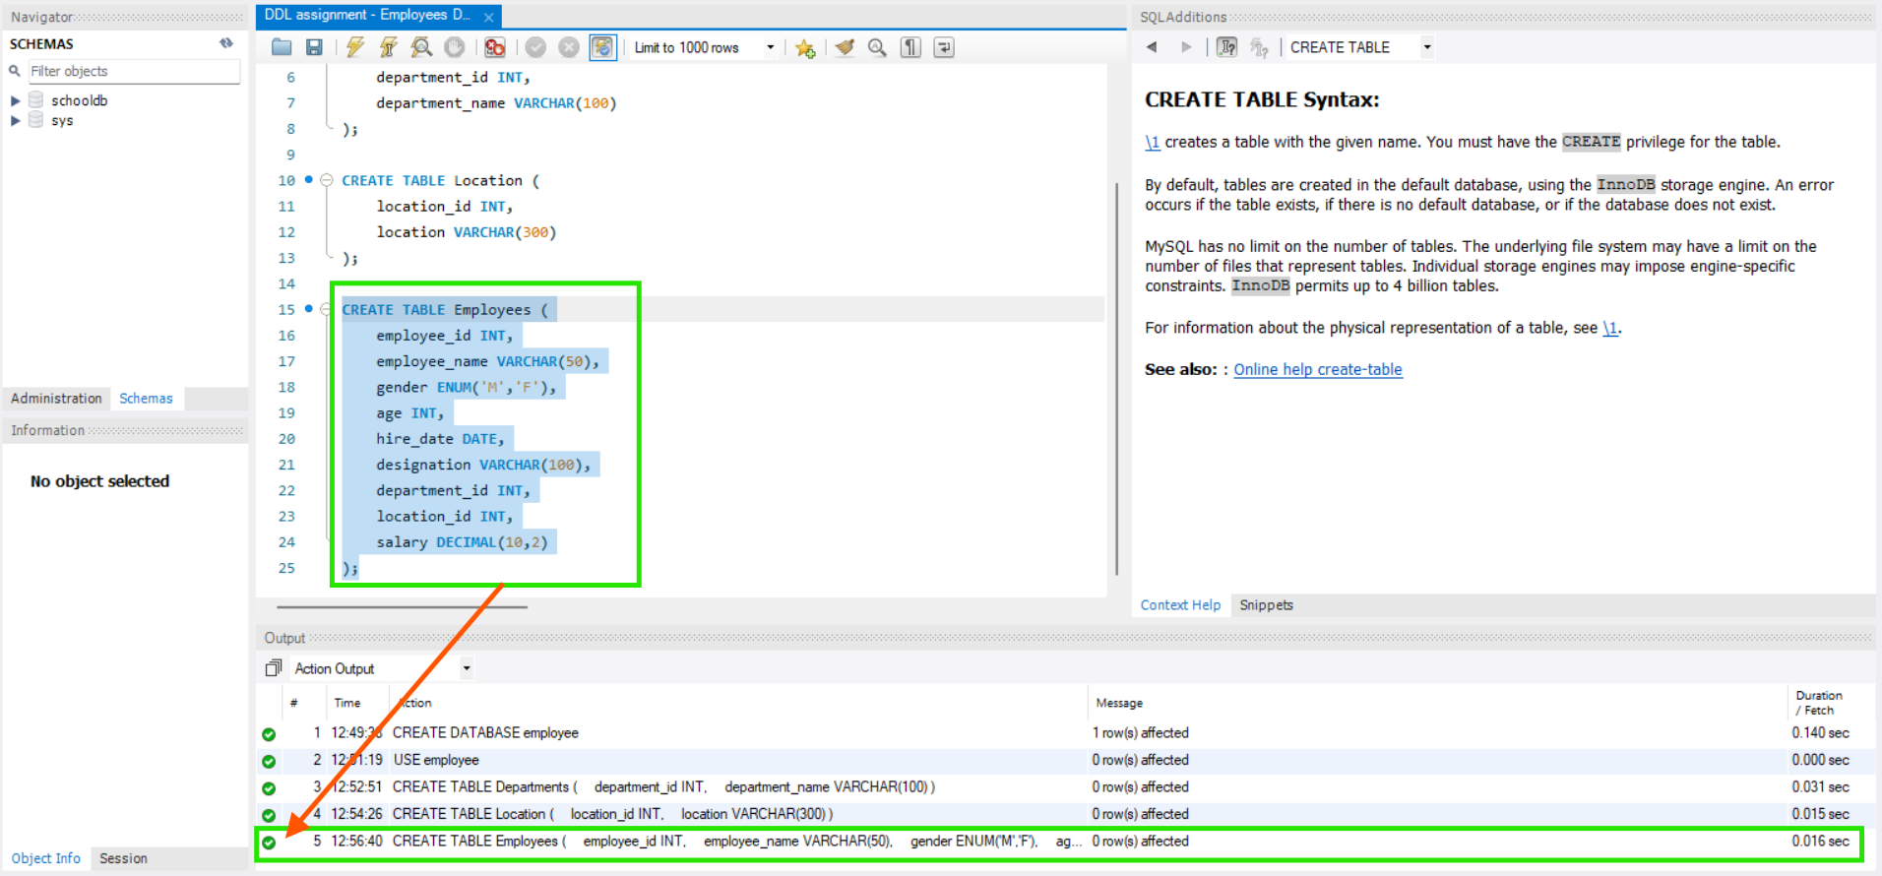

3) ALTERING TABLE STRUCTURE:
3.1) ADD A NEW COLUMN "EMAIL" TO THE "EMPLOYEES" TABLE.
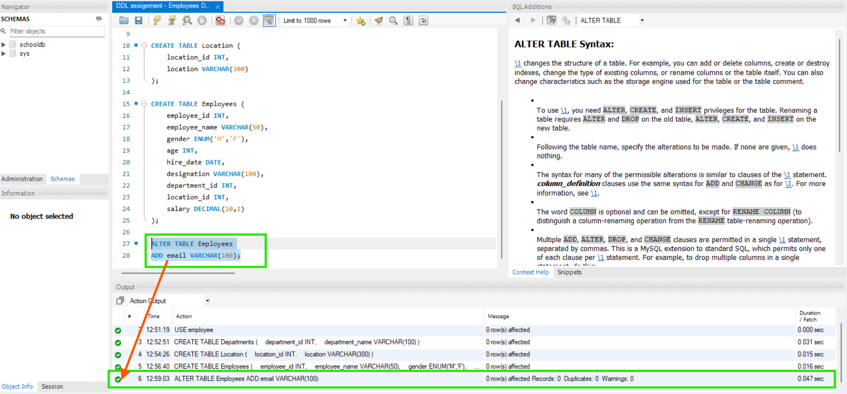
3.2) MODIFY THE "DESIGNATION" COLUMN TO 'VARCHAR(255)'.
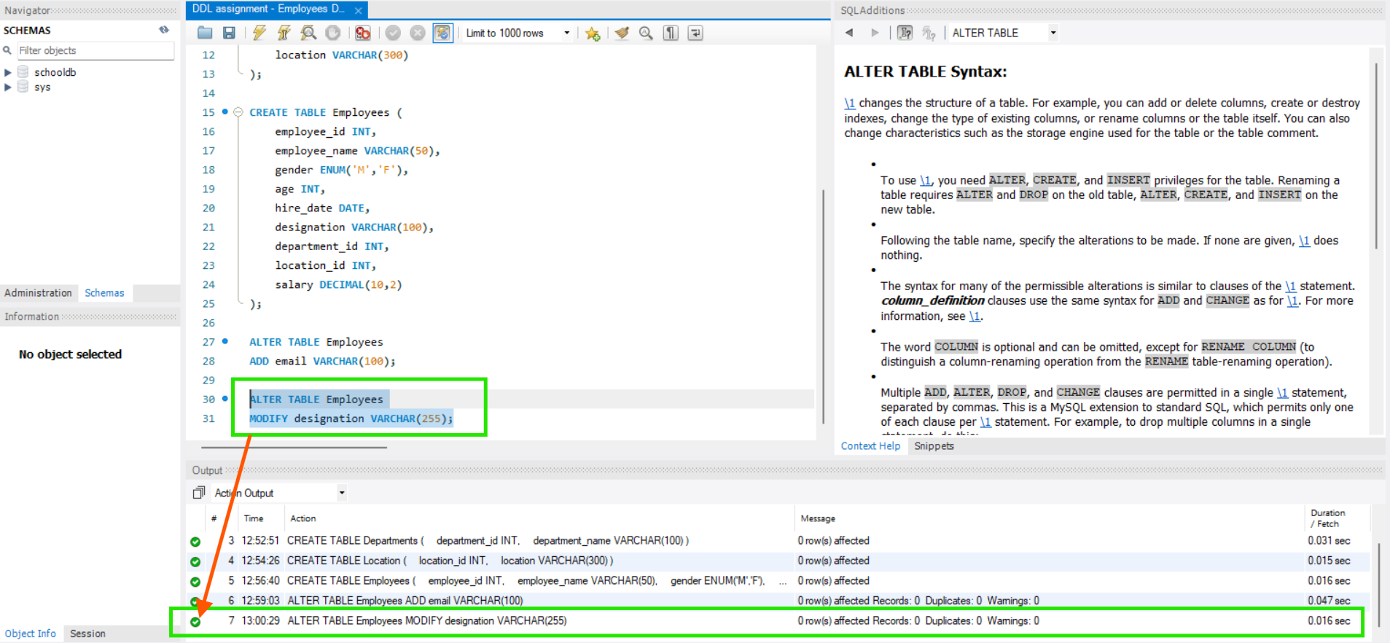

3.3) DROP THE "AGE" COLUMN FROM THE "EMPLOYEES" TABLE.
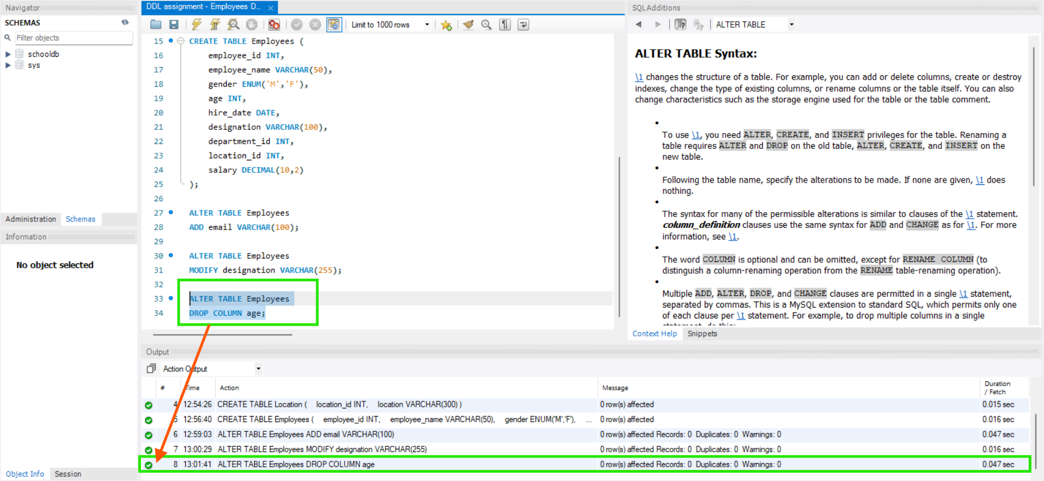
3.4) RENAME THE "HIRE_DATE" COLUMN TO "DATE_OF_JOINING".
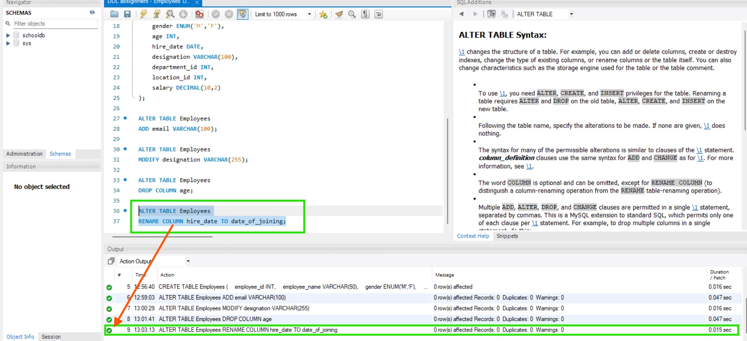

4) RENAMING TABLES:
4.1) RENAME "DEPARTMENTS" TABLE TO "DEPARTMENTS_INFO".
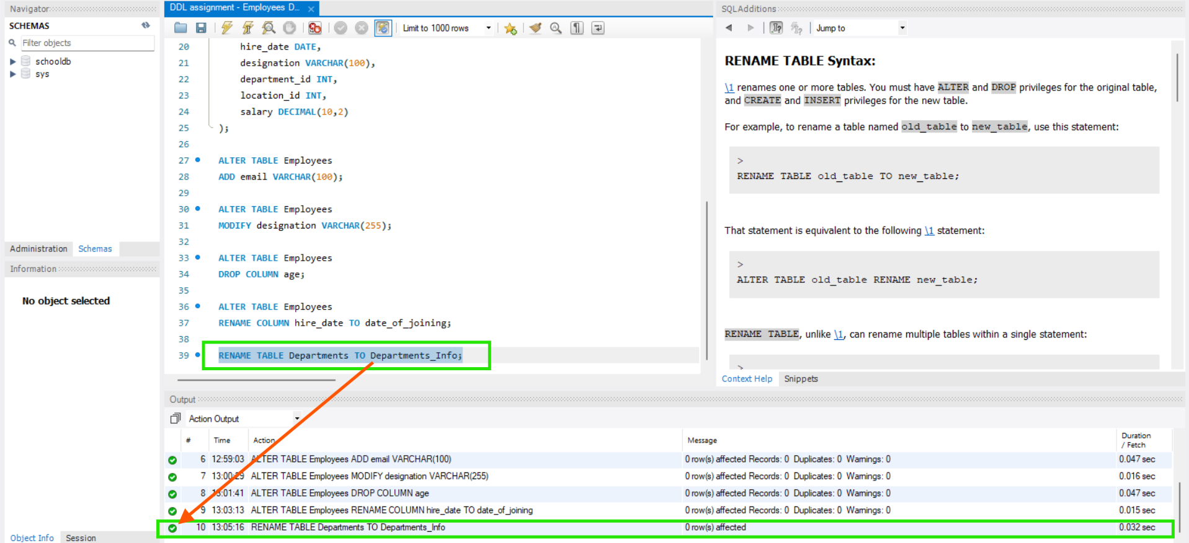
4.2) RENAME "LOCATION" TABLE TO "LOCATIONS".
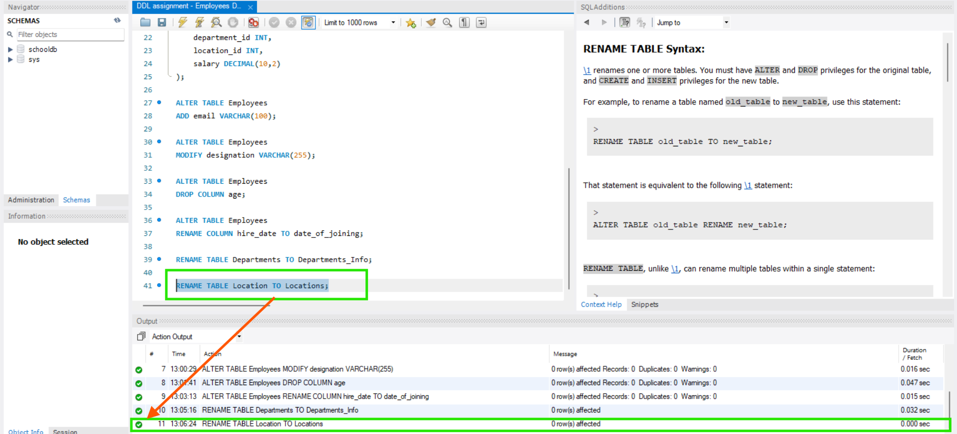

5) TRUNCATE AND DROP COMMANDS:
5.1) TRUNCATE THE "EMPLOYEES" TABLE TO REMOVE ALL ROWS.
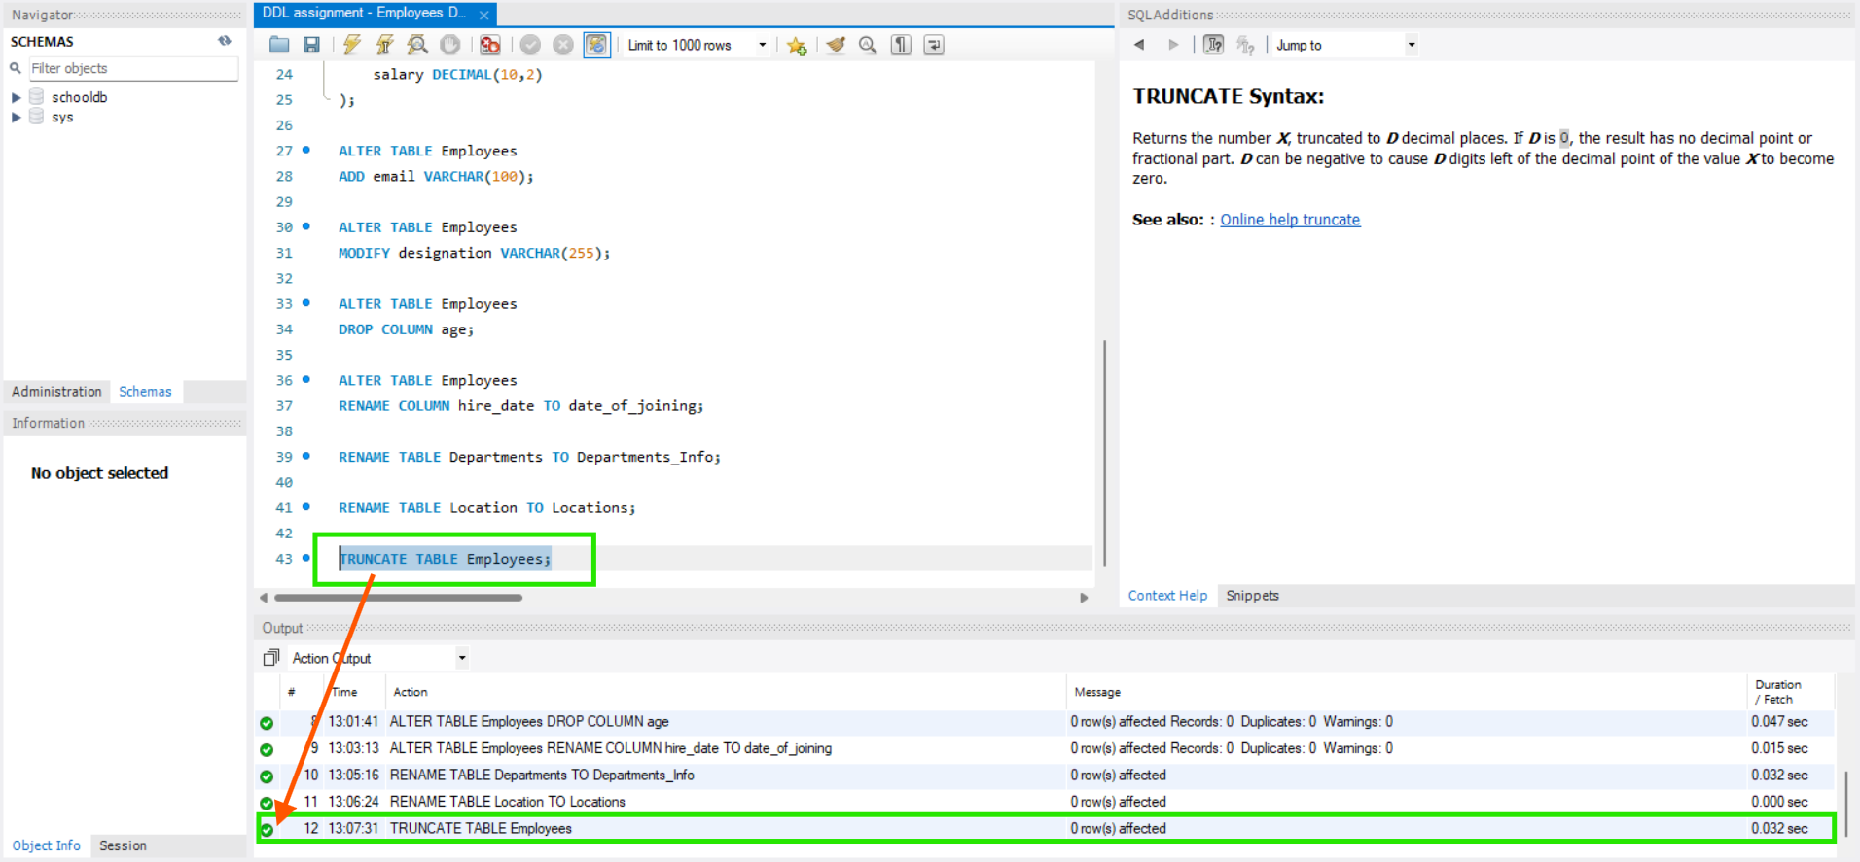
5.2) DROP THE "EMPLOYEES" TABLE.
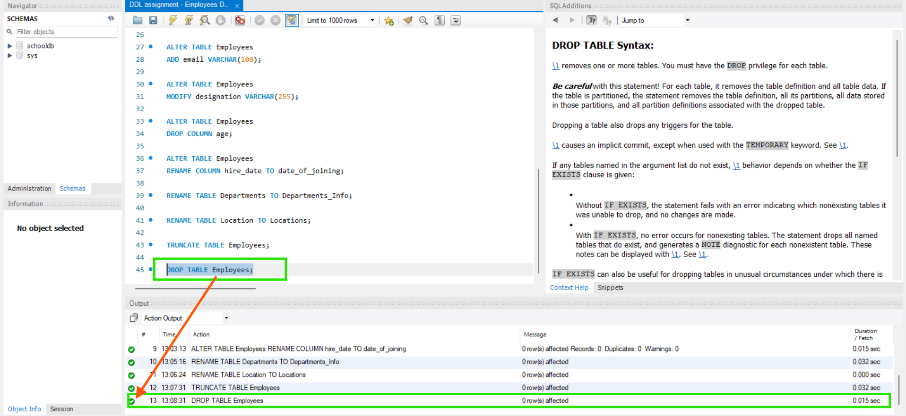

5.3) DROP THE "EMPLOYEE" DATABASE.
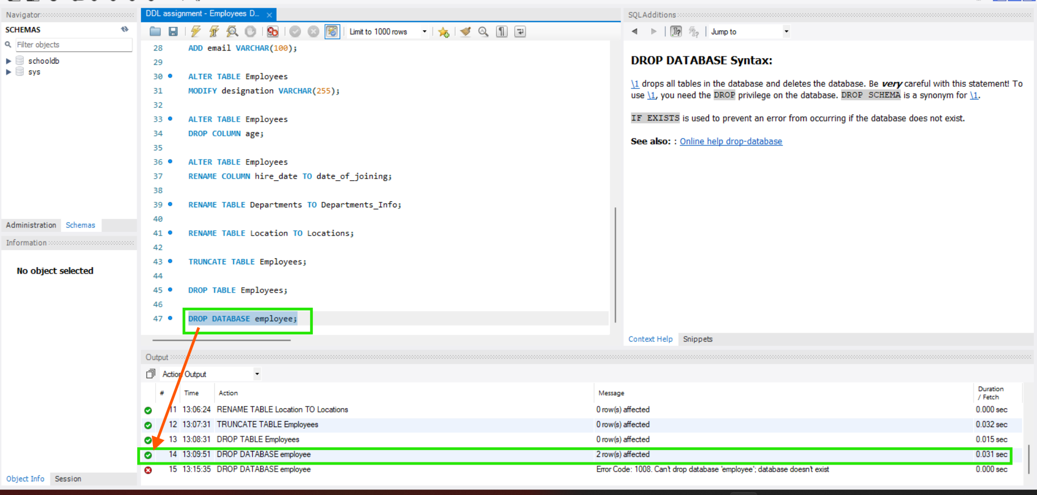

6) RECREATING THE DATABASE WITH CONSTRAINTS:
6.1) CREATE THE "EMPLOYEE" DATABASE AGAIN.
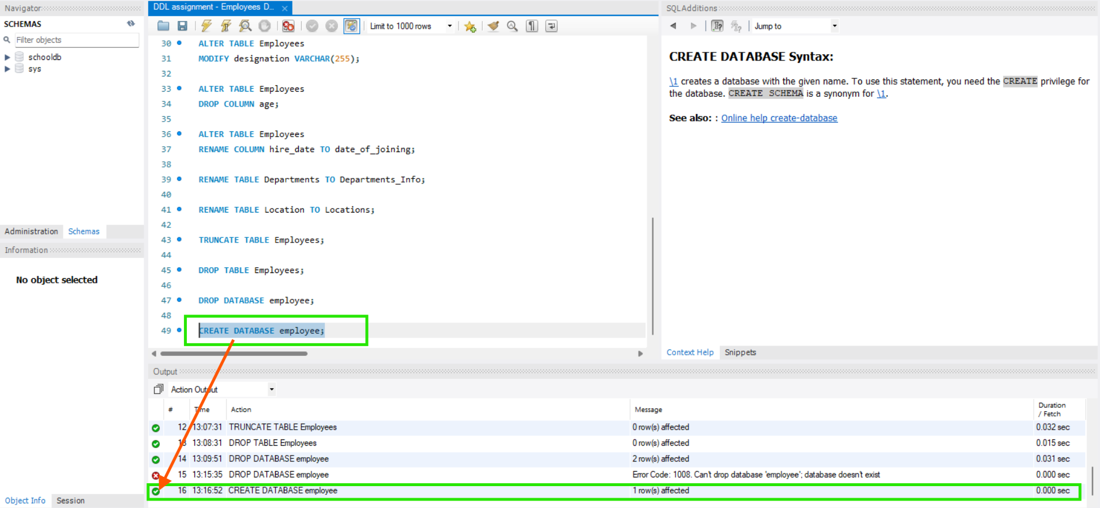
6.2) SELECT THE "EMPLOYEE" DATABASE.
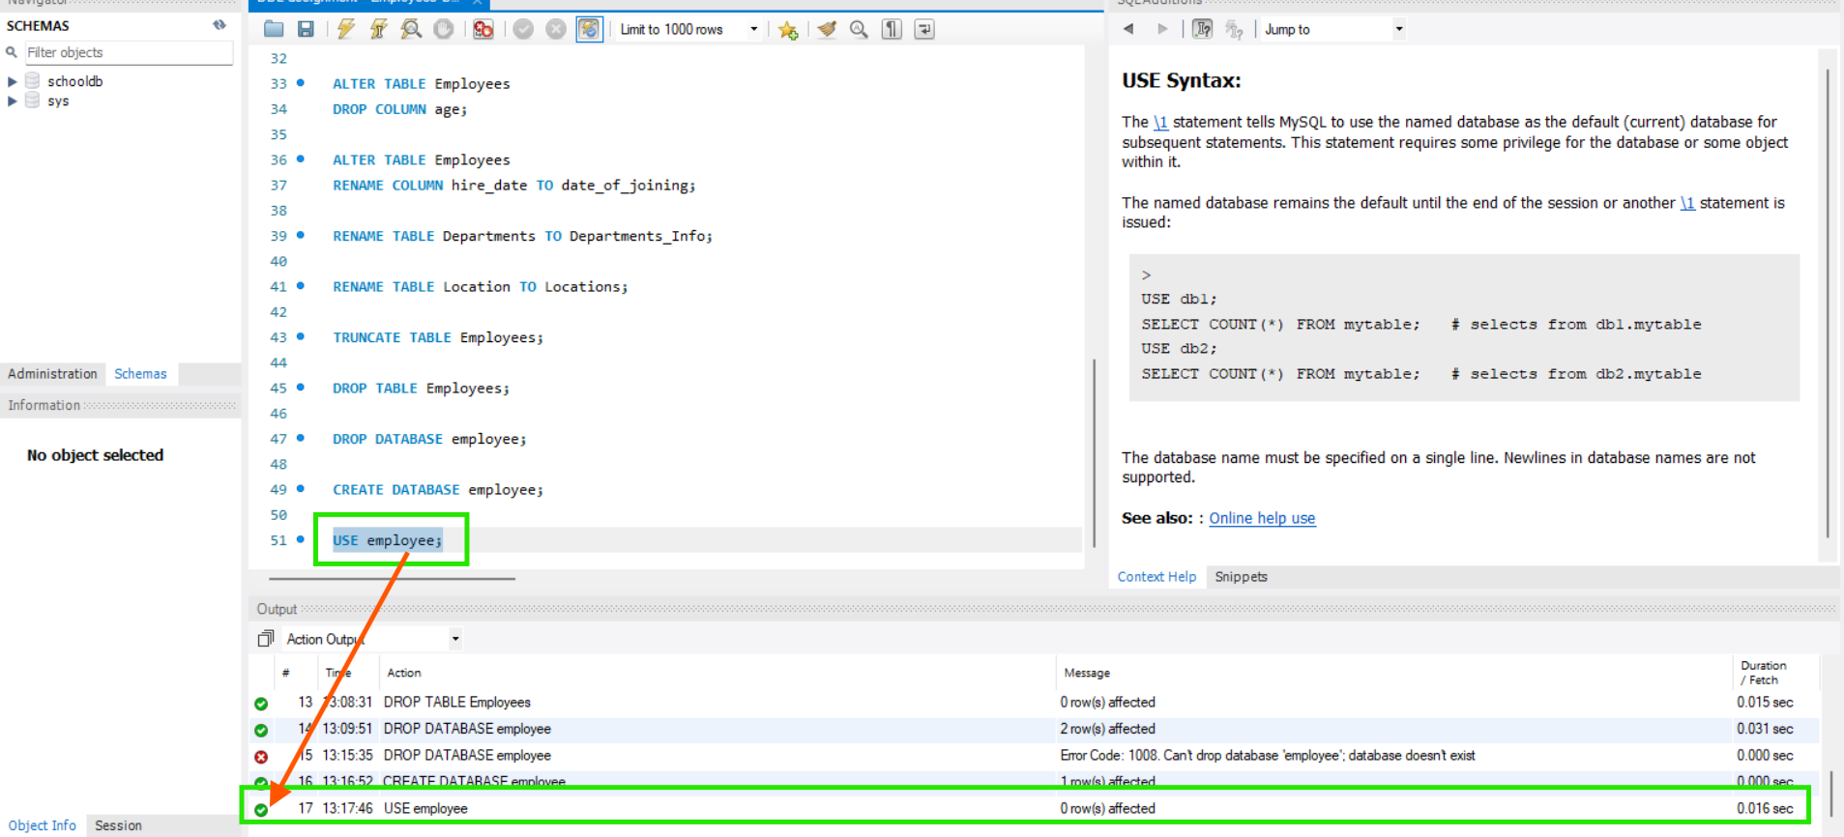

6.3) CREATE TABLE "DEPARTMENTS" WITH 'PRIMARY KEY', 'NOT NULL' AND 'UNIQUE' CONSTRAINTS.
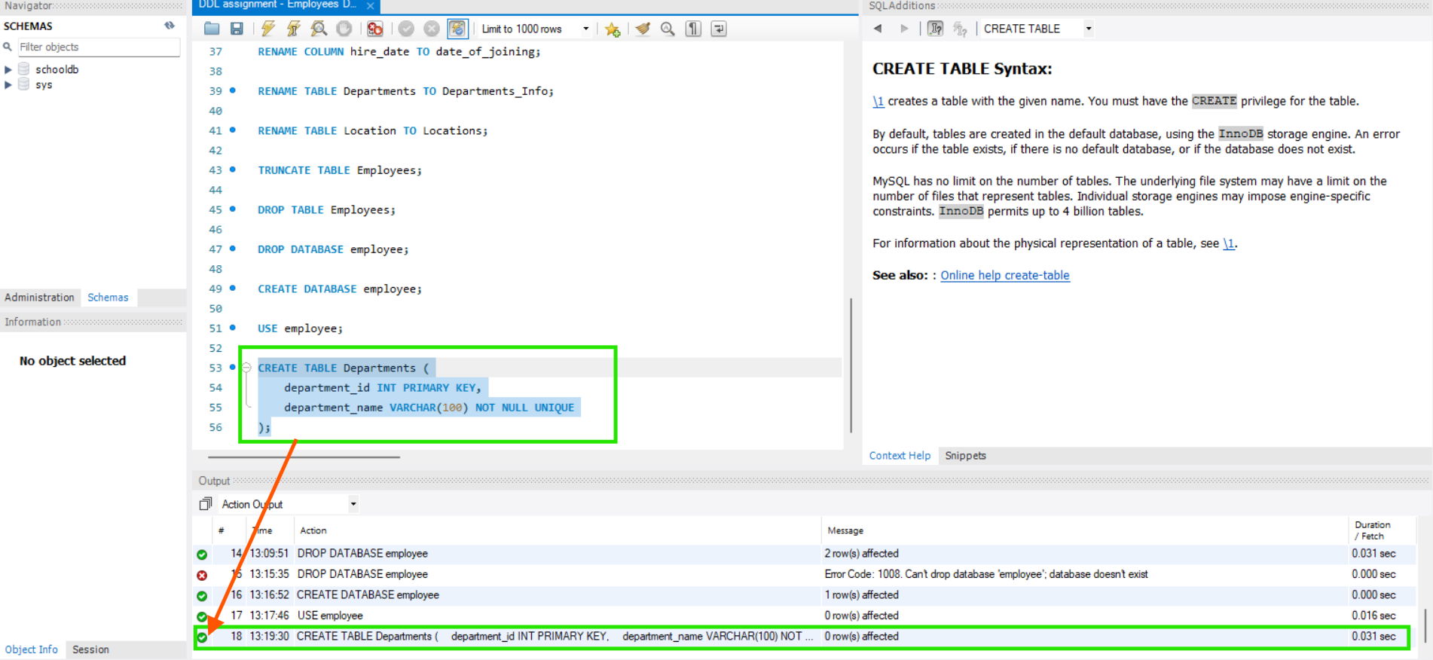
6.4) CREATE TABLE "LOCATION" WITH 'PRIMARY KEY AUTO_INCREMENT', 'NOT NULL' AND 'UNIQUE' CONSTRAINTS.
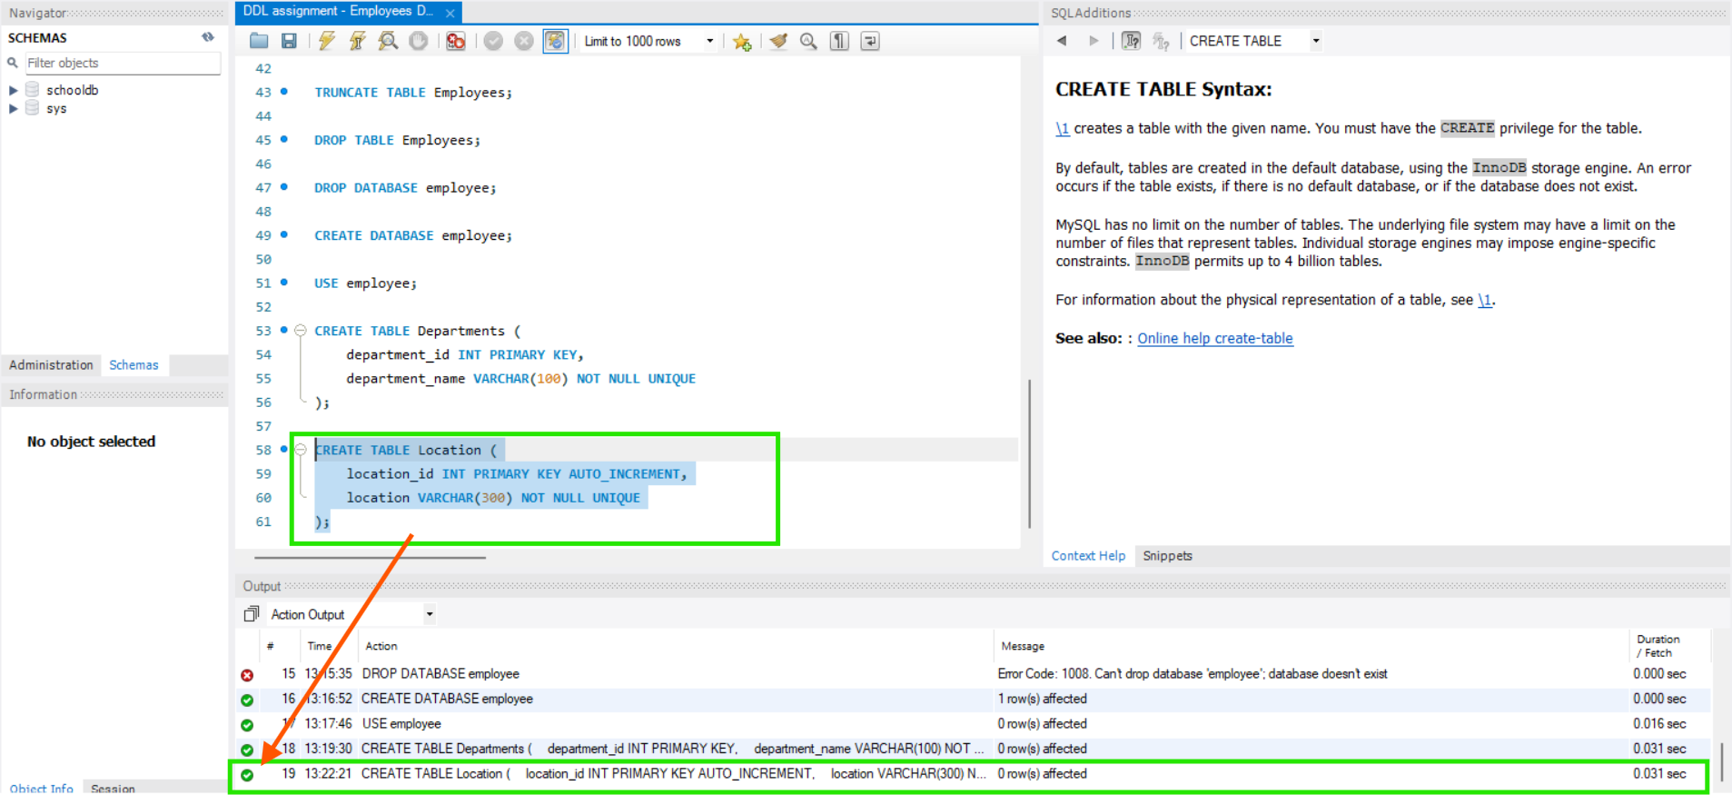

6.5) CREATE TABLE "EMPLOYEES" WITH 'PRIMARY KEY', 'NOT NULL', 'CHECK', 'DEFAULT' AND 'FOREIGN KEY' CONSTRAINTS.
